Battery Gauge – CGEA1.3

Functional Description

The purpose of the Battery Gauge is to inform the driver of the vehicle’s battery voltage. It is not a linear indication of battery voltage.

The Hot at all Times (B+) input to the cluster is the input sensed to determine gauge position. This input is filtered and translated into a pointer position on the battery gauge (voltmeter).

Interfaces

Interface Context Diagram (I/O Block Diagram)
Figure 1 Battery Gauge Context Diagram

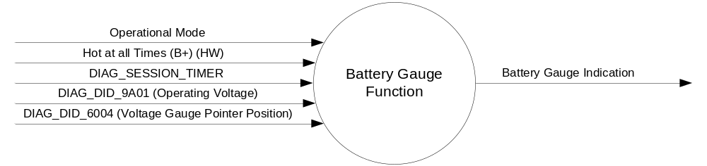

Inputs

- Internal
  - DIAG_SESSION_TIMER
  - Operational_Mode
  - Hot at all Times (B+) (HW)
  - DIAG_DID_9A01 (Operating Voltage)
  - DIAG_DID_6004 (Voltage Gauge Pointer Position)

Outputs
Battery Gauge Indication

Function/Performance

Operational Modes

Mode | Differentiating Vehicle Conditions
Sleep Mode | Battery Gauge needle at “Rest Position”
Limiting Mode | Battery Gauge needle at “Rest Position”
Normal Mode | Battery Gauge needle at “Battery Gauge” indication
Crank Mode | Battery Gauge needle at Battery Gauge indicator or at last “Battery Gauge” indication determined in Normal Mode.

Voltage Levels

Refer to Cluster Features table located in the Master SPSS

Human-Machine Interface

Visual

Indicator Graphics / Display Format
Figure 1 Battery Gauge Indication
Low
Normal
High

A
B
J
E
D
C
I
H
G
F

Gauge Position |  | Description
A |  | Low Stop
B |  | 2° below center of low
C |  | Center of low
D |  | 2° above center of low
E |  | Starting edge of norm band
F |  | Flat Zone
G |  | Ending edge of normal band
H |  | 2° below center high
I |  | Center of high
J |  | 2° above center of high

- The "High" graduation mark shall be on the right side of the indicating field, except when using a vertically arranged field, in which case the "High" graduation shall be on the top of the field.

Indicator Color Coordinates

- Reference section COLOR & ILLUMINATION REQUIREMENTS (GRAPHICS)
- It is recommended that the "High" and "Low" graduation mark be colored red.

Indicator Characteristics

Description of Gauge | Scale Range | Scale Span | Operating Span
North American | “L” to “H” | 0 – 86 angular degrees | -4 to 89 angular degrees

Audio

None

Switch Control Logic

Not Applicable

System Accuracy

- Shall indicate within 100 msec the calculated Filtered_Voltage_Value, which is the value of the Hot At All Times input after filtering.

Operation: Performance and Functional

Subsystem Algorithm Flowchart / State Diagram

Operational Mode | Filtered_ Voltage_Value | Gauge Pointer (angular degrees) |  |  | Graphic Position
Operational Mode | Filtered_ Voltage_Value | Target | Minimium | Maximum | Graphic Position
Normal or Crank | <=8 | 0 | -3 | 3 | C
Normal or Crank | 9.6 | 7.7 | 4.7 | 10.7 | E
Normal or Crank | 11.7 – 15.0 | 46 | 43 | 49 | F
Normal or Crank | 16.9 | 78.3 | 75.3 | 81.3 | G
Normal or Crank | >=18 | 89 | 84 | 91 | I
All other cases |  | -4 | -7 | -1 | A

Operation Description (supports algorithm flowchart /state diagram)

- Filtered_Voltage_Value is the values of the Hot at All Times input as sensed at the micro with an averaging filter applied that has a time constant of 0.5 to1 second.
- Target Gauge Pointer values are determined using the table in 1.3.5.1 with linear interpolation for values between entries in the table.

Function Safety Classification (EMC)

B

Memory Storage

Parameter Name | Description | Value at Battery Connect | Value at Module Wake-up
Filtered_Voltage_Value | Filtered value of Voltage_Value | 0 | 0

Prove Out

No

Error Handling

None.

Missing Message Strategy

None.

Diagnostics

Self Test

None

Engineering Test Mode

Reference section “Dealer / Engineering Test Mode (ETM)”

Part II Performance

Supported Diagnostic DIDs
Number | DID / CommonID Name | DID  Type | Units | Size | Data  Type | Resolution | Offset | Minimum | Maximum | Comments/  Information
9A01 | Operating Voltage | Numeric | V | 8 | Unsigned | 0.1 | 0 | 0 | 25.5 | unfiltered voltage at the cluster input pin
6004 | Voltage Gauge Pointer Position | Numeric | % | 8 | Unsigned | 1 | 0 | 0 | 255 | Voltage Gauge Pointer Position

Reference Specification
- Func. Criticality EC-0048
- Mod. PWR-up / Reset EC-0049
- Low-High Vol. Perform. EC-0058
- Jump Start EC-0062
- Voltmeter Accuracy IS-0004
- Instr. & Gauges (indic. Grad) IS-0015
- Gauge Durab. IS-0033
- Oper. Voltage Perf. IS-0052
- Oper. Voltage Func. IS-0053
- Sys. Audible Noise IS-0103
- Pointer Waver IS-0108
- Instr. Scale Dir. IS-0127
- Vibration - Gauge Perf. IS-0326
- Symbol Usage 01-0238 / 01-0239
- Symbol Leg. 01-0240
- Placement - Parts Loc. 03-0001
- Coolant Temp. Gauge - Normal Op 04-0034
- Glare/Reflections 16-0068
- Reflection 17-0018
- Robust Sound Quality 17-0032
- Harmony: Graphics / Font / Ill. 17-0040
- Placement Vis. ID 17-0051
- Ergo - Access. 17-0052
- Ergo - Operablility 17-0053
- Control & Display Loc. 17-0060
- Logical grouping Function and Usage 17-0062
- Assoc. of Controls with Disp. & elem. 17-0063
- Ill. Controls & Disp. 17-0074
- Id. Legibility 17-0081
- ID. Coding / Labeling 17-0083
- Logic of Op. 17-0120
- Op. Stereotypes 17-0121
- Interpretation 17-0122
- Feedback 17-0124

Revision History
SPSS Module Revision History

Revision Level | Name | Change Description | Date
1.0 | V. Patel | No updates for CGEA1.3. Based on CGEA Battery Gauge STSS V1.0 | 05/10/2010

